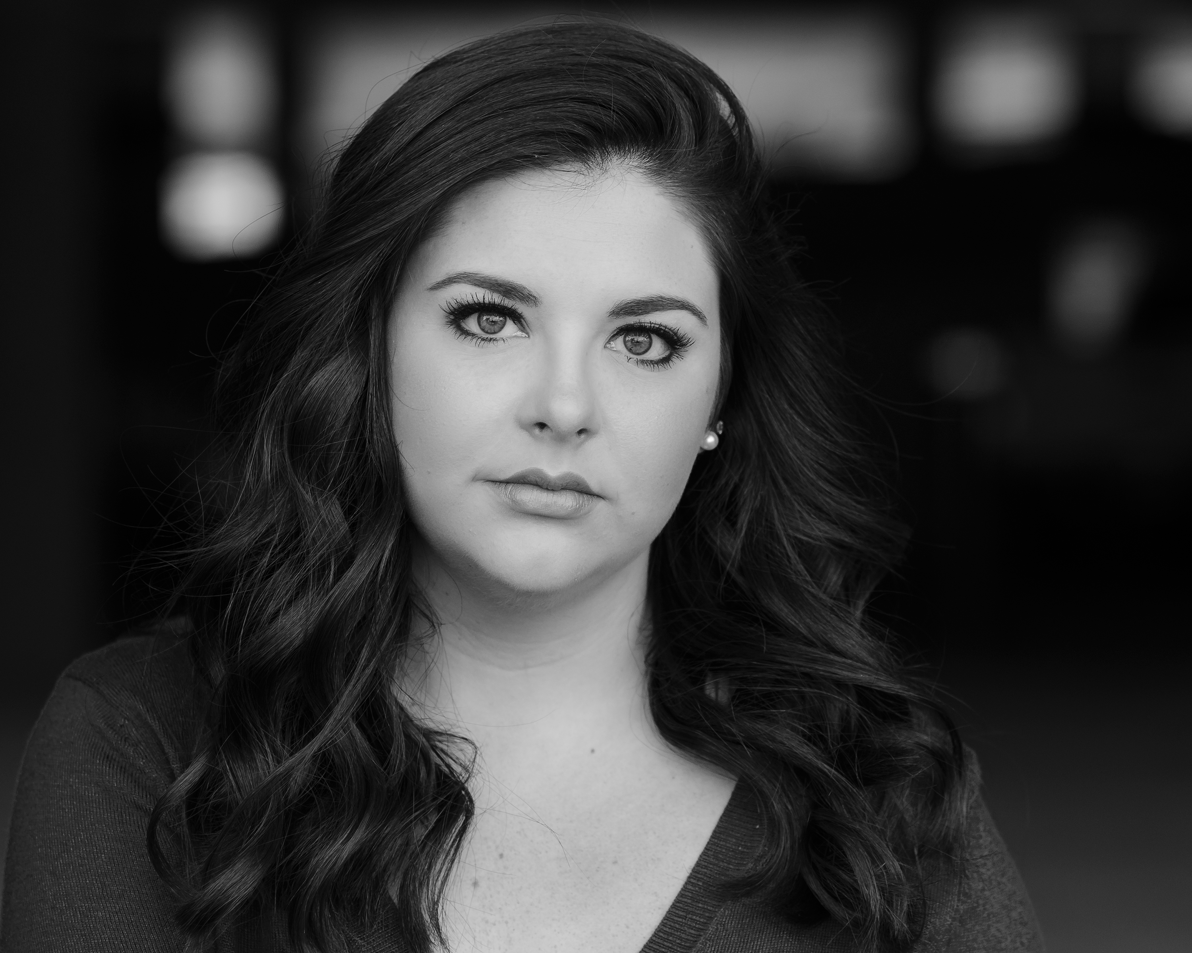**Marie Videau**

**Phone:** (850)-390-1438

**Email:** marielvideau@gmail.com

Hair: Brown Eyes: Green Height: 5’4’’

Range: Mezzo-Soprano

**THEATRE**

Seduced Miami The University of Alabama

42nd Street Ensemble/Female Swing The University of Alabama

Lend Me a Tenor Julia The University of Alabama

Boeing Boeing Bertha u/s The University of Alabama

Heathers Veronica Sawyer UA Senior project (April ’16)

Cakewalk Marie Laveau The University of Alabama

Blood Wedding Ensemble The University of Alabama

Xanadu Kira The Ashmore Theatre

Legally Blonde Serena Pensacola State College

The Crucible Abigail The Ashmore Theatre

Anything Goes Charity The Ashmore Theatre

Romeo and Juliet Chorus The Ashmore Theatre

Guys and Dolls Lt. Brannigan Pensacola State College

Personals and Proposals Kelly The Ashmore Theatre

Seven Brides for Seven Brothers Ensemble Pensacola State College

**Education/Training**

The University of Alabama BA Musical Theatre 2016

Acting Seth Panitch, Allison Hetzel

Shakespeare Seth Panitch

Voice/Repertoire Bill Martin, Emily Herring, Debra Ross

Dance Stacy Alley (Jazz, Tap), Quanping Guo (Ballet),

John Virciglio (Jazz), Sarah Berry (Modern)

Master Classes Matt Davenport, Chet Walker, Jason Robert Brown, Sheri Sanders, Renee Glicker

Directing Jeff Tangeman

**Special Skills**

Works well with kids, Can Sight Read well, Basic Piano, Car Alarm, Roller-skating, Florida Drivers License, Passport